Step 8. Measure Points
Within this section, you will be taking multiple measurements using a UTS, a data collector running Siteworks, and the Hexcal program to calculate distances. This process will involve moving the machine a number of times and transferring data between a laptop using Hexcal and the data collector.
Tools required:
- SPS9x0 Total Station
- Data Collector with Siteworks
- Digital Level
- Plumbob
- Prism (target)
- 3D Printed Measure up Tools
- Laptop with Hexcal loaded
Setup UTS in a position where all points are visible. This includes the A pin as well as all other excavator’s linkages points that are required for this machine type and a 2D configuration.
Once the UTS is set up, do not move the total station or the machine itself with the exception of the bucket, stick, and boom to put it later into measure up positions.
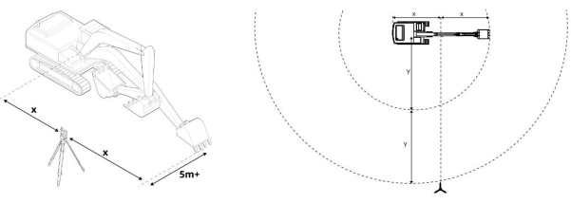
Measure Position 1
1. Place machine into position 1
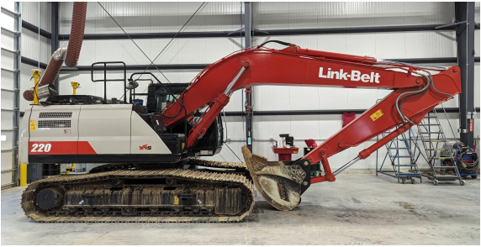
2. Shoot all necessary points, if necessary including the points for auto systems
(see table in step 7) and export the CSV file from Siteworks onto a USB drive.
3. Enter the Monitor Menu within the Web Interface app, navigate to Monitor and
open the Machine Position section to look up the body pitch and roll. Make note
of these values for use within Hexcal.
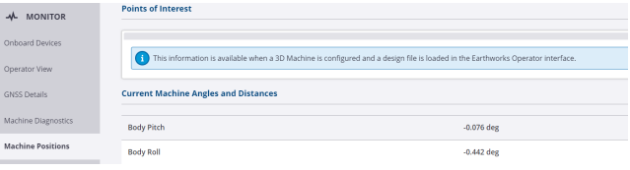
4. For Swing Boom Machines the Body Pitch and Body Roll will not be shown until
a first measure is completed, so for the first measure-up, use a spirit level for
that.
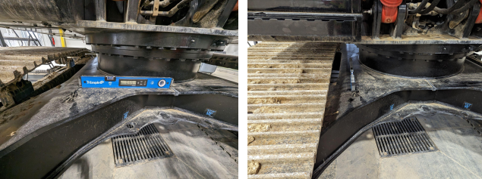
5. Load the .CSV file into Hexcal. Take care to enter first the correct Decimal
Separator (Period), Delimiter(Comma), and Point Order(P,N,E,Z). Enter the Body
Pitch and Roll measured in the last step and press calculate
Note: Right UP for roll and Front UP for pitch equals a positive number

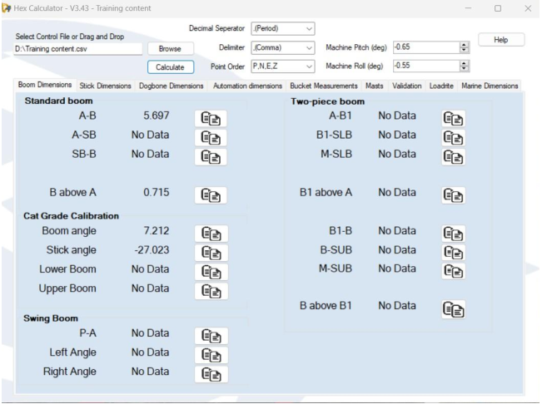
6. Open the install assistant in the Web UI as shown in step 1 and view the
measure-up part. To enter the calibrated values from Hexcal.
7. First tab are the Body dimensions.
Both values are used to scale the machine model on the display. This measurement is not critical for accurate guidance, but it is important for display usability. An error less than ± 50 mm (± 2 inches) is required.
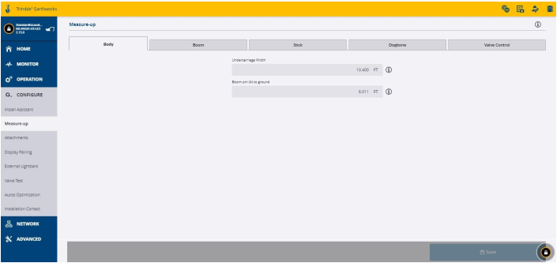
- Measure the machine’s Undercarriage width utilizing a tape measure.
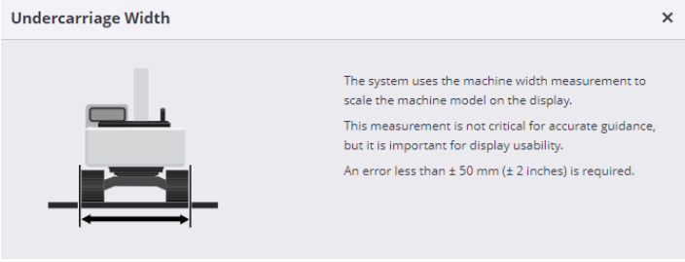
b. Using the Siteworks COGO tool, measure the distance between Pin A and
the ground utilizing the Track point. It is also possible to utilize a tape
measure to get this measurement.
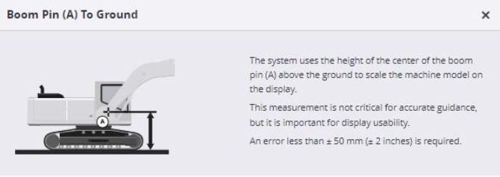
8. On each tab of the measurement screen, enter the requested measurements with the
values obtained from Hexcal.
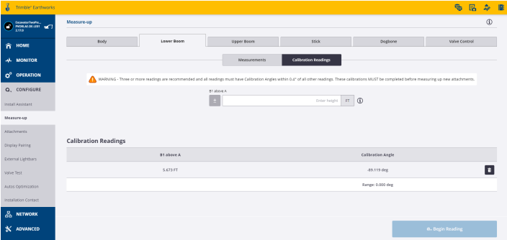
9. As part of the Boom or Lower boom the measurement of the A pin relative to the COR
is required. If the machine has a 2D configuration, these values are critical for accurate
guidance. An error less than ± 1mm (± 0.05 inches) is required. If the machine is a 3D
installation, the values will be overwritten during 3D calibration.
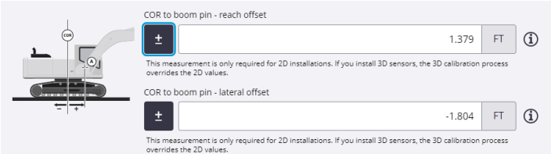
10. After completing the measurements in all tabs, add the first calibration reading
for each of the upper tabs (Lower Boom/Upper Boom/Stick/Dogbone).
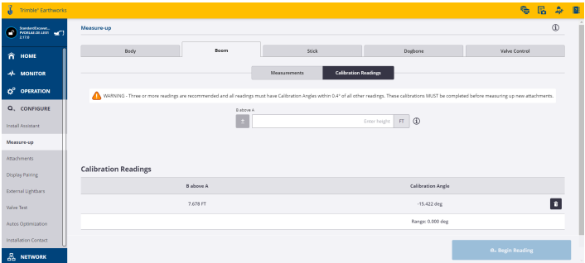
Note: At the end three or more readings are recommended and all readings must have Calibration Angles within 0.4° of all other readings.

Measure Position 2
1. Place the machine into Position
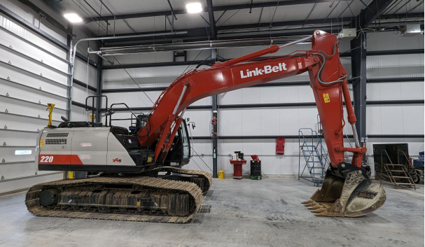
2. Create a new job in Siteworks and shoot all points from position 1 again. From
here on, the points for an auto system no longer need to be measured. This is
only necessary once and was done in the first position.
3. Export this data from Siteworks and import it into Hexcal.
4. Enter the second Calibration Readings screens within the Measure Up menu in
Earthworks and enter the requested information gathered from Hexcal.
5. Leave UTS setup and targets on the machine as position 3 has yet to be shot in
step 11.

